New I/O Modules from JUMO and Recorder App

Efficient data recording and process visualization in the PLC and I/O modules with maximum efficiency in minimum space
Press release
PI 2509

Page 1 of 2

Editorial information:
Michael Klose, Press Office
Phone: +49 661 6003-2346
Fax: +49 661 6003-882346
Email: michael.klose@jumo.net

Technical information:
Michael Wiener,
Global Product Manager PLCs Strategic
Phone: +49 661 6003-2933
Email: michael.wiener@jumo.net

Niklas Hack,
Global Product Manager
Data Recording & Evaluation /
Transmitter
Phone: +49 661 6003-2884
Email: niklas.hack@jumo.net

JUMO GmbH & Co. KG

Moritz-Juchheim-Straße 1
36039 Fulda, Germany

Phone: +49 661 6003-0
Fax: +49 661 6003-500

Email: mail@jumo.net
Internet: www.jumo.net

JUMO, a system and solution provider, presents 2 significant innovations in the latest system version for the JUMO variTRON controller family, which considerably increase efficiency and flexibility in industrial automation.

“On the one hand, customers can look forward to a truly unique selling point with the recorder app for the JUMO variTRON controller family, since the function of a paperless recorder is moving to the PLC. On the other hand, with the new JUMO I/O system for the JUMO variTRON PLC family, users can expect a family of modules that is 'state of the art',” explains Michael Wiener, Global Product Manager PLCs Strategic at JUMO.

The new I/O modules for the JUMO variTRON PLC family are characterized by a slim design and high channel density. The modules have been designed in a way that maximizes the number of inputs and outputs in the smallest possible space. This facilitates efficient use of the available space in the control cabinet. Their reaction time has been optimized, which means that they react quickly to input and thereby allow precise process control.

The recorder app for the JUMO variTRON 500 touch offers an innovative recorder function directly on the device for the first time. It enables efficient data recording and process visualization directly on site, without the need for additional hardware or software.

This functionality is available on the web for the DIN rail devices JUMO variTRON 300 and JUMO variTRON 500, which makes flexible and mobile use possible. “JUMO offers its customers a USP because they can dispense with a complete device in the form of a classic paperless recorder,” emphasizes Niklas Hack, Global Product Manager Data Recording & Evaluation / Transmitter at JUMO.

The recorder app that is integrated into the JUMO variTRON family is characterized by its high degree of efficiency in data recording and process visualization. It enables users to acquire and analyze process-relevant data in real time. This makes JUMO PLC systems unique on the market.

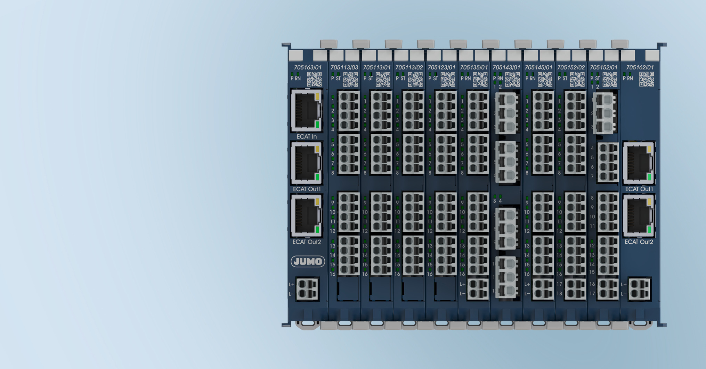

Photo: JUMO
Image caption: The new I/O modules for the JUMO variTRON family offer a wide range of advantages and innovations that significantly increase efficiency and flexibility in industrial automation.

The JUMO corporate group, based in Fulda, Germany employs over 2400 people worldwide. It is a leading system and solution provider in the field of industrial sensor and automation technology. JUMO products are used in industries such as thermoprocess technology, heating, ventilation and air conditioning, food and beverage, renewable energies, and water and wastewater. The company posted a turnover of 301 million euro in 2024.
Press release
PI 2509

Page 2 of 2

