Reliable and Fast Process
Visualization at a Glance
Press release
PI 2315

Page 1 of 2

Editorial information:
Michael Klose, Press Office
Phone: +49 661 6003-2346
Fax: +49 661 6003-882788
Email: michael.klose@jumo.net

Technical information:
Michael Wiener, Product Manager
Phone: +49 661 6003-2993
Fax: +49 661 6003-882788
Email: michael.wiener@jumo.net

JUMO GmbH & Co. KG

Moritz-Juchheim-Strasse 1
36039 Fulda, Germany

Phone: +49 661 6003-0
Fax: +49 661 6003-500

Email: mail@jumo.net
Internet: www.jumo.net
Smart solution JUMO variTRON 500 touch
can be used in many industries

JUMO variTRON 500 touch provides users with a smart solution for simple automation applications. It can be used in a wide range of industries.

These include plant engineering, mechanical engineering, measurement, control, automation, industrial furnace construction, food industry, pharmaceutical/medical/biotechnology, energy and water supply, as well as water and environmental engineering.

It is the first JUMO device with a capacitive touchscreen. The central processing unit and display are built into one device. JUMO now provides an entire PLC family. The product is available in 7" and 10.1" as well as with IP65 and IP69K (excellent robustness) protection type.

"We work with market standards like CODESYS V3.5 and Node-RED as development environments," explains product manager Michael Wiener. CODESYS is the central element of the PLC.

The JUMO variTRON 500 touch enables clear process and plant visualizations as well as user interfaces. Full connectivity to systems and components is provided due to support for numerous fieldbus systems (such as PROFINET IO controller and EtherCAT master) as well as modern communication protocols like OPC UA. The JUMO variTRON 500 touch is an example of reliable control technology with independent PID controllers, including autotuning function.

JUMO variTRON 500 is based on a powerful CPU with an 800 MHz quad-core processor. The software has a modular structure based on a Linux platform and uses the CODESYS V3.5 programming environment SP17 to create PLC programs. Another special feature is a customer-specific configuration and process data editor. In addition, individual applications can be created using the modern programming environment Node-RED.

The central processing unit has 2 USB host ports, 3 Ethernet interfaces, and 1 RS485 port as connection options. Up to 32 wireless JUMO Wtrans sensors can be connected via a wireless gateway for various purposes including measuring temperature or pressure.

The intuitive evaluation and visualization of up to 240 logged process data units from the JUMO variTRON 500 touch automation system is possible with the browser-based software solution JUMO smartWARE Evaluation. Individual dashboards allow targeted and fast access to recorded process data. Manipulation detection based on digital certificates ensures a high degree of data security.
Press release
PI 2315

Page 2 of 2

Photo: JUMO
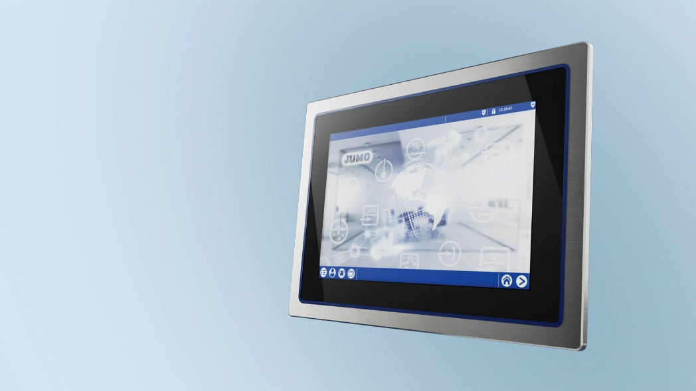

Image caption: JUMO variTRON 500 touch provides users with a smart solution for simple automation applications.

The JUMO corporate group, based in Fulda, Germany, employs over 2,500 people worldwide. It is the leading system provider in the field of industrial sensor and automation technology. JUMO products are used in industries such as heating and air conditioning, food and beverage, renewable energies, and water and wastewater. The company posted a turnover of 307 million euro in 2022.

