Reliable and Compact Level Monitoring
Press release
PI 2281

Page 1 of 2

Editorial information:
Michael Brosig, Press Office
Phone: +49 661 6003-2788
Fax: +49 661 6003-882788
Email: michael.brosig@jumo.net

Technical information:
René Krug, Product Manager
Phone: +49 661 6003-9144
Fax: +49 661 6003-889144
Email: rene.krug@jumo.net

JUMO GmbH & Co. KG

Moritz-Juchheim-Strasse 1
36039 Fulda, Germany

Phone: +49 661 6003-0
Fax: +49 661 6003-500

Email: mail@jumo.net
Internet: www.jumo.net
JUMO ZELOS C01 LS − a robust industrial version which is maintenance-free and flexible

The JUMO ZELOS C01 LS capacitive level detector identifies the level of liquids and solids. This device can also be used in pressurized tanks or pipes. In an industrial environment, it shows its advantages in applications with requirements for overflow and dry-running protection or for media detection.

JUMO ZELOS C01 LS can be used in liquids or bulk solids with temperatures between -40 and +200 °C. Thanks to the unique auto-calibration feature, point level measurement is detected reliably and with long-term stability. In addition, after configuration, the 2 switching outputs can automatically distinguish safely between measurement medium and cleaning media or foam. Even adhesions do not present a problem for the reliable sensor. The product design contributes to miniaturization in sensor technology so that compact systems can be implemented. Mounting is easily achieved with a standard torque wrench. Since the seal to the medium goes through the sensor tip, no separate seal is required, thereby eliminating the possibility of a mix-up.

Short-circuit and reverse polarity protection provides additional safety for the JUMO ZELOS C01 LS. An antivalent electrical circuit enables the detection of line faults such as a cable break. A firmware update profile allows the sensor to be updated while installed so that plant downtime is minimized. PNP, NPN, push-pull, and IO-Link are available as output signals. A 360° illuminated status display enables easy recognition of the sensor status according to NAMUR and VDI/VDE.

The level detector has protection types IP67/IP69. All parts in contact with the medium are made of PEEK with a homogeneous surface roughness of less than R_{a} 0.8 µm. It is available with extensive approvals for applications in the food industry, railroad technology, and shipbuilding. Furthermore, the requirements according to intrinsically safe explosion protection, the Water Resources Act (WHG), and electrical safety according to UL are met.

The JUMO ZELOS C01 LS monitors containers, protects pumps from running dry or controls valves, PLC inputs, and warning signals. Typical applications include storage tanks for solid and liquid food, water and wastewater, and sand or granules. Media recognition is automatic and can be specifically taught with and without software if required.
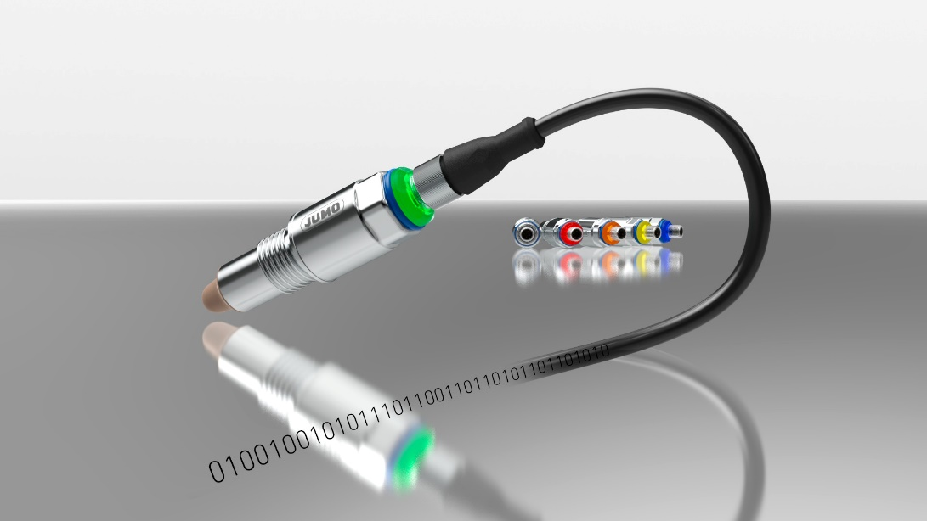
Photo: JUMO

Image caption: The JUMO ZELOS C01 LS level detector is available with extensive approvals for applications in the food industry, railroad technology, and shipbuilding.
Press release
PI 2281

Page 2 of 2

The JUMO corporate group, headquartered in Fulda, employs more than 2400 people worldwide and is one of the leading manufacturers in the field of industrial sensor technology and automation. JUMO products are used around the globe in industries such as heating and air conditioning, food and beverage, renewable energies, and water and wastewater. The corporate group encompasses 5 branch offices in Germany, 25 subsidiaries in Germany and abroad, and more than 40 agencies around the world. The company posted a turnover of 281 million euro in 2021.
