Intelligent Automation for Industry 4.0
Press release
PI 2259

Page 1 of 2

Editorial information:
Michael Brosig, Press Office
Phone: +49 661 6003-2788
Fax: +49 661 6003-882788
Email: michael.brosig@jumo.net

Technical information:
Manfred Walter, Product Manager
Phone: +49 661 6003-498
Fax: +49 661 6003-881498
Email: manfred.walter@jumo.net

JUMO GmbH & Co. KG

Moritz-Juchheim-Strasse 1
36039 Fulda, Germany

Phone: +49 661 6003-0
Fax: +49 661 6003-500

Email: mail@jumo.net
Internet: www.jumo.net
JUMO smartWARE Evaluation for the analysis and visualization of measurement data

The browser-based software solution JUMO smartWARE Evaluation enables intuitive analysis and visualization of process data from the JUMO variTRON automation system. Individual dashboards allow targeted and fast access to recorded process data. Manipulation detection based on digital certificates ensures a high degree of data security.

Data is the gold of the 21st century. Efficient data acquisition and analysis are elementary components of Industry 4.0. JUMO smartWARE Evaluation is a software solution that is now available for the JUMO variTRON automation system that enables browser-based process data analysis via customizable dashboards.

JUMO smartWARE Evaluation is installed centrally on desktops, local servers, or in the cloud using Docker technology. Additional installation of software or add-ons by the user is not necessary. This saves costs for the administration of the system. Access then takes place via common web browsers. Once set up, JUMO smartWARE Evaluation enables an unlimited number of users to analyze and visualize up to 1500 signals – worldwide.

An intuitive device and plant overview allows for quick navigation and selection of dashboards. It also enables a plant-wide batch search and analysis.

The individual design of the dashboards is an important step in the direction of a smart factory as processes can be sustainably optimized based on the collected data.

Data security is the top priority for JUMO smartWARE Evaluation. The recorded raw data is securely transferred to a datastore and archived by the JUMO variTRON 300 or 500 via Rest API using the data diode principle. Traceability of the recorded data is also ensured in the event of a configuration change or device replacement.

Analysis takes place in a separate area (Dataview) and is supported by tamper detection based on digital certificates so that verifiable process data can be provided reliably and quickly for critical audits.

JUMO is also breaking new ground in terms of planning and cost reliability. Billing occurs via a licensing model and is based on the number of signals required. The model is scalable. Fees for users do not apply.

Photo: JUMO
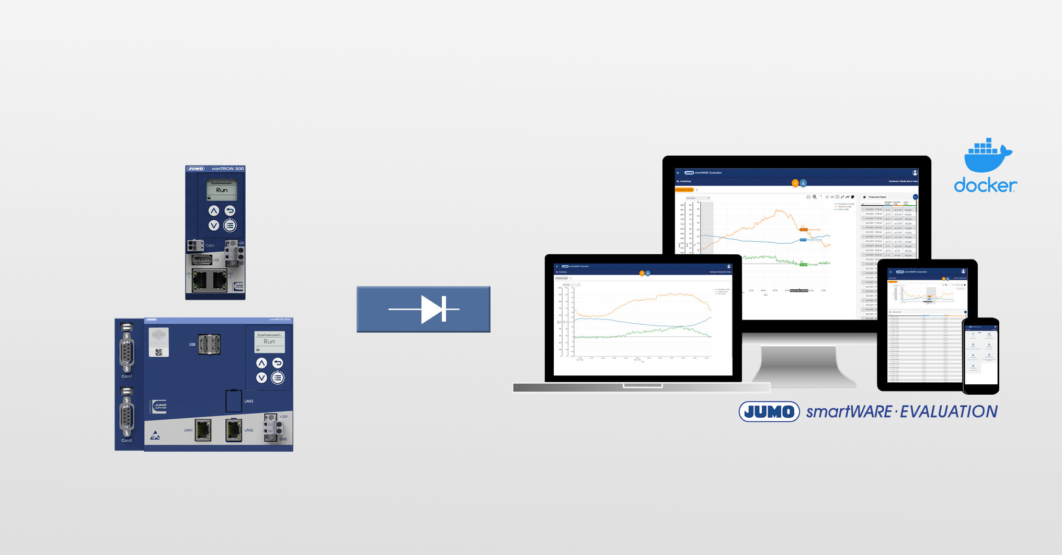

Image caption: JUMO smartWARE Evaluation enables the analysis of up to 1500 process signals.

Press release
PI 2259

Page 2 of 2

The JUMO corporate group, headquartered in Fulda, employs more than 2400 people worldwide and is one of the leading manufacturers in the field of industrial sensor technology and automation. JUMO products are used around the globe in industries such as heating and air conditioning, food and beverage, renewable energies, and water and wastewater. The corporate group encompasses 5 branch offices in Germany, 25 subsidiaries in Germany and abroad, and more than 40 agencies around the world. The company posted a turnover of 238 million euro in 2020.


