Electronic Transformer for Special Requirements
Press release
PI 2236

Page 1 of 2

Editorial information:
Michael Brosig, Press Office
Phone: +49 661 6003-2788
Fax: +49 661 6003-882788
Email: michael.brosig@jumo.net

Technical information:
Andreas Kraus, Product Manager
Phone: +49 661 6003-2394
Fax: +49 661 6003-882394
Email: andreas.kraus@jumo.net

JUMO GmbH & Co. KG

Moritz-Juchheim-Strasse 1
36039 Fulda, Germany

Phone: +49 661 6003-0
Fax: +49 661 6003-500

Email: mail@jumo.net
Internet: www.jumo.net
JUMO IPC 300 features a high degree of reliability and low operating costs

The JUMO IPC 300 is an electronic transformer with amplitude control in the performance range up to 40 kW. It was developed for the control of heating loads that previously required an additional transformer for power control.

Due to the integrated amplitude control, the mains current and the mains voltage of the JUMO IPC 300 are proportional to the required power of the heating element. The acquisition of additional compensation equipment is therefore no longer necessary.

In addition, the power converter reduces malfunctions such as flicker or harmonics so that it contributes to higher plant availability. Consistent energy demand decreases reactive power and reduces current peaks. This way, the JUMO IPC 300 lowers energy costs.

The integrated resistance limitation protects against overheating in the upper temperature range and thereby extends the service life of molybdenum disilicide heating elements. Low maintenance requirements combined with longer operating times reduce the operating costs.

An external current sensor monitors residual currents and detects housing shorts in the heating elements. Heating elements with large temperature coefficients change their heat output very strongly relative to their operating temperature. The power controller of the IPC 300 detects this and compensates for such an error.

Other strengths of the JUMO IPC 300 include its easy operation, configuration, and startup. The compact device has a plain text display and a keypad. By using the USB interface, the parameters can be easily transferred via the setup program. A voltage supply is not required. As a result, the JUMO IPC 300 is the right solution for mechanical and plant engineering, the process industry, and furnace construction.

Photo: JUMO
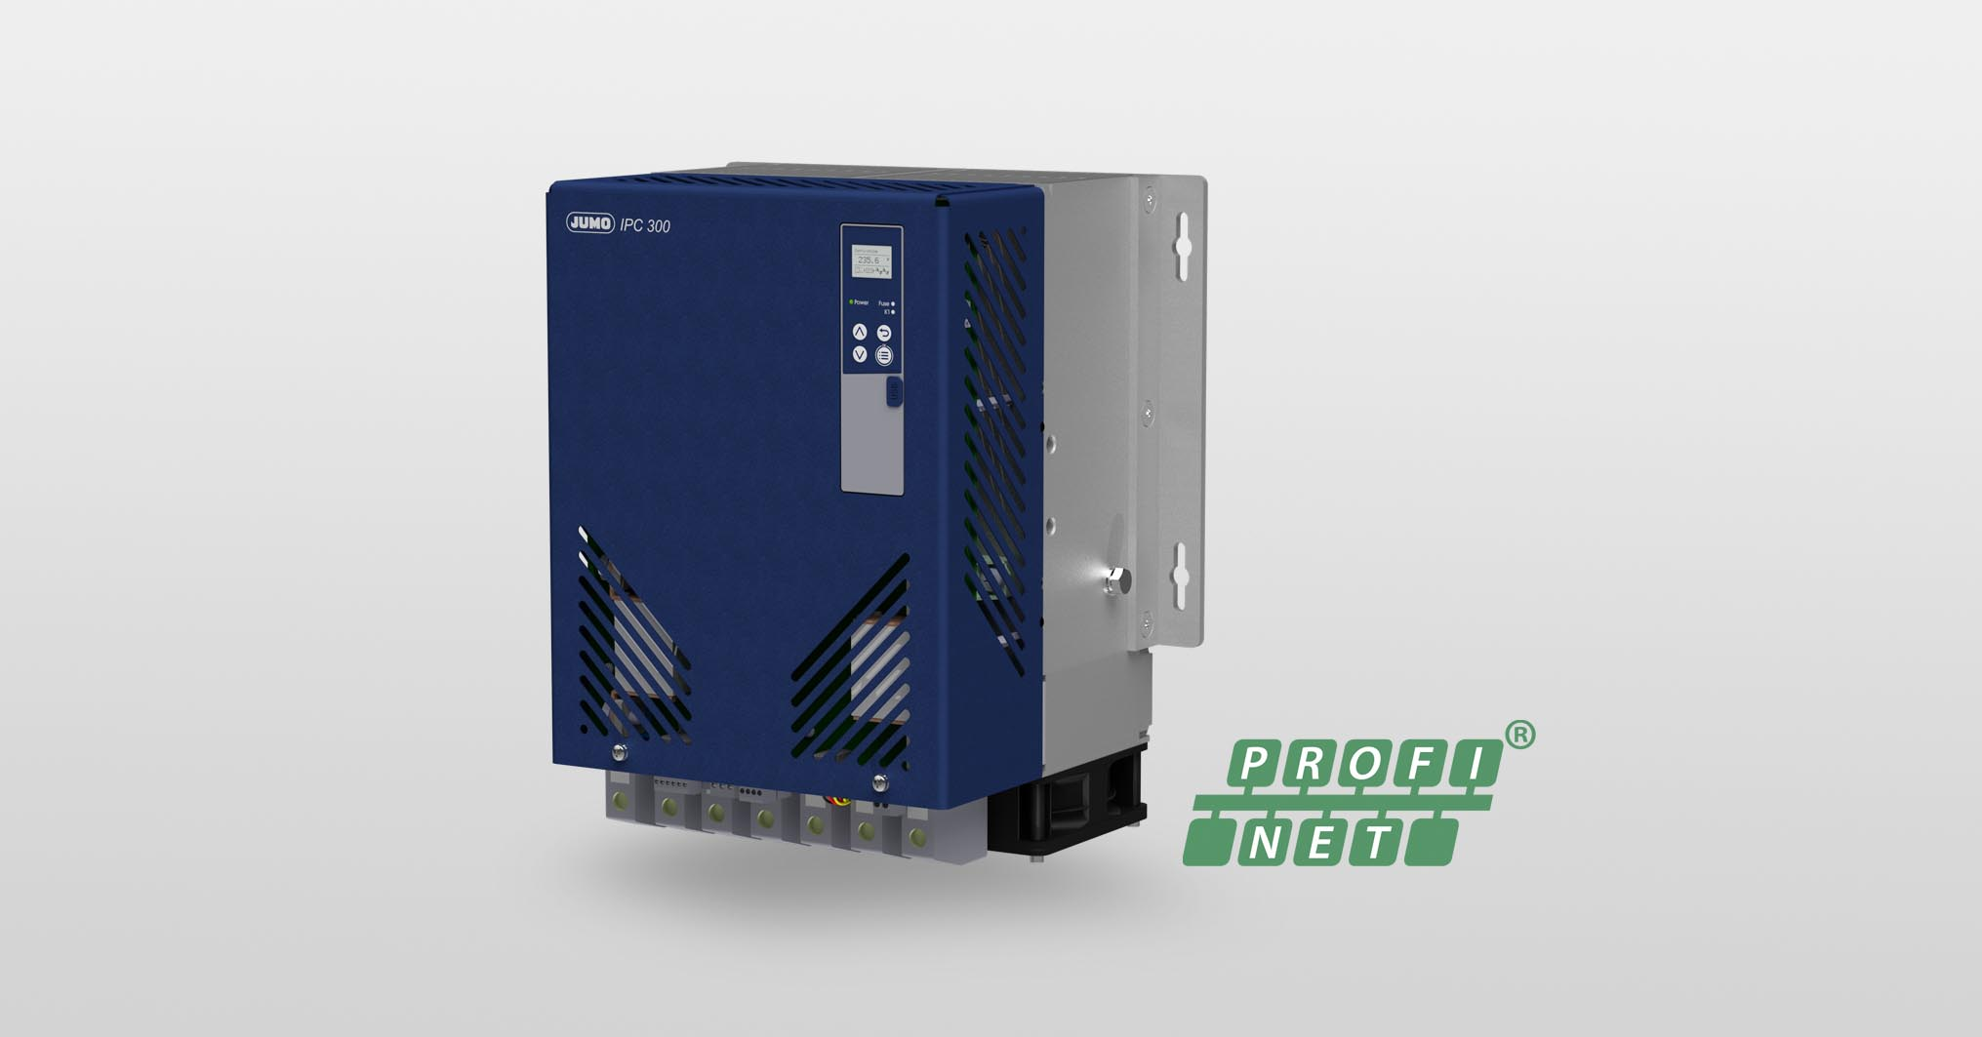

Image caption: The JUMO IPC 300 electronic transformer features simple startup and low maintenance requirements.
Press release
PI 2236

Page 2 of 2

The JUMO corporate group, headquartered in Fulda, Germany employs around 2 400 people worldwide and is one of the leading manufacturers in the field of industrial sensor and automation technology. JUMO products are used around the globe in industries such as heating and air conditioning, food and beverage, renewable energies, water and wastewater, and industrial furnace construction. The corporate group encompasses 5 branch offices in Germany, 25 subsidiaries in Germany and abroad, and more than 40 agencies around the world. The company posted a turnover of 253 million euro in 2019.


