JUMO Technology for the Digital Age
Press release
PI 2217

Page 1 of 3

Editorial information:
Michael Brosig, Press Office
Phone: +49 661 6003-238
Fax: +49 661 6003-881238
Email: michael.brosig@jumo.net

Technical information:
Nico Müller, Product Manager
Phone: +49 661 6003-2879
Fax: +49 661 6003-882879
Email: nico.mueller@jumo.net

JUMO GmbH & Co. KG

Moritz-Juchheim-Strasse 1
36039 Fulda, Germany

Phone:+49 661 6003-0
Fax: +49 661 6003-500

Email: mail@jumo.net
Internet: www.jumo.net
Automation 4.0 with the JUMO Cloud and JUMO smartWARE SCADA

Global data volumes are growing exponentially as a result of digitization. More and more industrial processes are being monitored, analyzed, and automated using sensors. The new JUMO Cloud and the JUMO smartWARE SCADA make an important contribution to the development of the intelligent factory of the future.
Press release
PI 2217

Editorial information:
Michael Brosig, Press Office
Phone: +49 661 6003-2788
Fax: +49 661 6003-882788
Email: michael.brosig@jumo.net

Technical information:
Nico Müller, Product Manager
Phone: +49 661 6003-2879
Fax: +49 661 6003-882879
E-mail: nico.mueller@jumo.net

JUMO GmbH & Co. KG

Moritz-Juchheim-Strasse 1
36039 Fulda, Germany

Phone: +49 661 6003-0
Fax: +49 661 6003-500

Email: mail@jumo.net
Internet: www.jumo.net

For many years, JUMO has been evolving into a supplier of industry-specific complete solutions for which JUMO also produces the complete hardware. The JUMO portfolio stretches from sensors for various physical measurands to controllers, paperless recorders, and powerful automation systems.

The JUMO Cloud is the next logical step in this development. It is based on the "Software as a Service" (SaaS) model, which is a cloud-based application software with a predefined user interface.

As an IoT platform for process visualization as well as collecting, acquiring, analyzing, and archiving data, the JUMO Cloud provides a global access point to measurement data using conventional web browsers. It is characterized by a high degree of security as well as valuable visualization, alarm, and planning functions. Customers can use the JUMO Cloud to monitor several distributed plants, processes, or sites in one dashboard, which, in turn, increases process reliability.

JUMO uses a redundant and certified infrastructure for data storage, as a result of which users save a significant amount of time. Professional reporting and export functions considerably reduce the effort required for data acquisition requiring proof. JUMO works exclusively with European data centers, which means users can rest assured that all GDPR standards are met.

The possibilities provided by the JUMO Cloud span from simple alarm messages through to condition monitoring and complete plant control. The Cloud has been configured to integrate seamlessly with the new hardware and software platform JUMO JUPITER, which is the key component in the equally new automation system JUMO variTRON.
Press release
PI 2217

Page 2 of 3

JUMO smartWARE SCADA was developed along with the cloud solution. This software solution based on the JUMO Cloud is located in the automation pyramid at the control level. JUMO smartWARE SCADA provides easy access to measurement data using conventional web browsers. It offers functions for process visualization as well as for evaluation and archiving the acquired data. Visualization occurs through an editor that has an integrated animation and test tool as well as vector-based, self-scaling process screens.

As a result, JUMO smartWARE SCADA is a highly scalable and high-performance digitization platform that supports manufacturing as well as work processes with efficient visualization, alarm, and planning functions. Thanks to its modern web-based interface, customers can access it without having to install any software. As a system that supports multiple clients, user rights can be configured on an individual basis. Security is guaranteed by end-to-end encryption with possible two-factor authentication using the latest technology.

When paying for the JUMO Cloud the customer can choose between a flat rate and a pay-per-use model. The cloud memory can be flexibly expanded and adapted to the respective customer's individual requirements. JUMO smartWARE SCADA allows variable and customer-specific pricing.

The JUMO Engineering team with its many years of expertise assists in the implementation of industry as well as project-specific cloud and SCADA applications. By combining high-quality JUMO hardware, a modern cloud-based environment, and innovative Engineering services, JUMO is able to offer a "comprehensive carefree package" for users from a diverse range of industries.

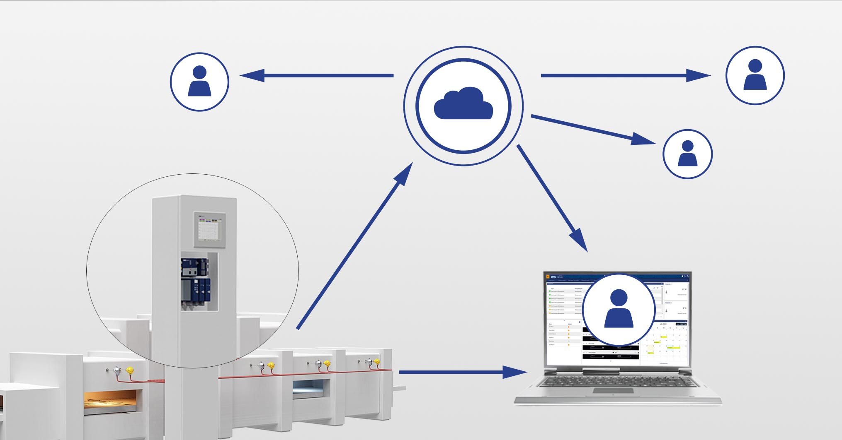
Photo: JUMO

Image caption: JUMO opens up completely new automation possibilities with the JUMO Cloud and JUMO smartWARE SCADA.
Press release
PI 2217

Page 3 of 3

The JUMO corporate group, headquartered in Fulda, Germany employs around 2 400 people worldwide and is one of the leading manufacturers in the field of industrial sensor and automation technology. JUMO products are used around the globe in industries such as heating and air conditioning, food and beverage, renewable energies, water and wastewater, and industrial furnace construction. The corporate group encompasses 5 branch offices in Germany, 25 subsidiaries in Germany and abroad, and more than 40 agencies around the world. The company posted a turnover of 253 million euro in 2019.


