The JUMO variTRON Automation System is Expanding
Press release
PI 2216

Page 1 of 2

Editorial information:
Michael Brosig, Press Office
Phone: +49 661 6003-238
Fax: +49 661 6003-881238
Email: michael.brosig@jumo.net

Technical information:
Michael Wiener, Product Manager
Phone: +49 661 6003-2993
Fax: +49 661 6003-882993
Email: michael.wiener@jumo.net

JUMO GmbH & Co. KG

Moritz-Juchheim-Strasse 1
36039 Fulda, Germany

Phone:+49 661 6003-0
Fax: +49 661 6003-500

Email: mail@jumo.net
Internet: www.jumo.net
Greater flexibility thanks to 3 new modules

The JUMO variTRON automation system impresses with its high performance speed and its modular operating philosophy. 3 new modules have now been added to the application areas.
Press release
PI 2216

Editorial information:
Michael Brosig, Press Office
Phone: +49 661 6003-2788
Fax: +49 661 6003-882788
Email: michael.brosig@jumo.net

Technical information:
Michael Wiener, Product Manager
Phone: +49 661 6003-2993
Fax: +49 661 6003-882993
Email: michael.wiener@jumo.net

JUMO GmbH & Co. KG

Moritz-Juchheim-Strasse 1
36039 Fulda, Germany

Phone: +49 661 6003-0
Fax: +49 661 6003-500

Email: mail@jumo.net
Internet: www.jumo.net

The 32-channel digital I/O module comes with 32 channels. Of these, 17 are configured as digital outputs by default. Up to 3 optional plug-in boards can each be used to connect 5 digital inputs or outputs. The digital input signals can be processed further in the JUMO variTRON central processing unit. Switching statuses are visualized with LED displays.

The new 2-port router module extends the central processing unit of the JUMO variTRON by 2 system bus outputs. As a result, the system bus can be transferred to the (equally) new 3-port router module on other DIN rails in the same or in other control cabinets up to 100 m away. This way, input and output modules can be distributed and the automation system can be arranged in a decentralized manner. Addressing via rotary coding switches can be implemented for special applications.

All 3 products allow a quick wiring of operating voltage and system bus by simply plugging the modules together.

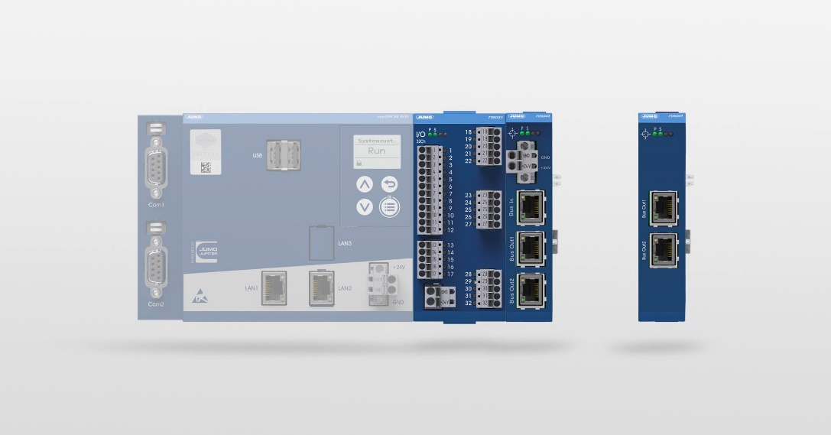
Photo: JUMO

Image caption: A 32-channel digital I/O module, a 2-port router module, and a 3-port router module are new additions to the JUMO variTRON automation system.
Press release
PI 2216

Page 2 of 2

The JUMO corporate group, headquartered in Fulda, Germany employs around 2 400 people worldwide and is one of the leading manufacturers in the field of industrial sensor and automation technology. JUMO products are used around the globe in industries such as heating and air conditioning, food and beverage, renewable energies, water and wastewater, and industrial furnace construction. The corporate group encompasses 5 branch offices in Germany, 25 subsidiaries in Germany and abroad, and more than 40 agencies around the world. The company posted a turnover of 253 million euro in 2019.


