Simple and Convenient Flow Measurement
Press release
PI 2175

Page 1 of 2

Editorial information:
Michael Brosig, Press Office
Phone: +49 661 6003-238
Fax: +49 661 6003-881238
Email: michael.brosig@jumo.net

Technical information:
Stefan Büchner, Product Manager
Phone: +49 661 6003-2475
Fax: +49 661 6003-882475
Email: stefan.buechner@jumo.net

JUMO GmbH & Co. KG

Moritz-Juchheim-Strasse 1
36039 Fulda, Germany

Phone: +49 661 6003-0
Fax: +49 661 6003-500

Email: mail@jumo.net
Internet: www.jumo.net
JUMO flowTRANS MAG S10 and H10 are suitable for a variety of media and processes

The 2 new devices from JUMO provide a simple introduction to the world of magnetic-inductive flow measurement. JUMO flowTRANS MAG S10 was designed for industrial standard applications in nominal widths from DN 3 to DN 2000 and the flowTRANS MAG H10 for hygienic applications in nominal widths from DN 3 to DN 100. Both devices can be used in liquid, conductive media with different properties such as viscosity, concentration, and density.

The universal transmitter electronics for various voltage supplies are new. Uncomplicated cabling enables a simple and fast startup. Diagnostic messages can be displayed in plain text on the illuminated display. The LCD display can be replaced if necessary.

For both versions, the conductivity of the measurement medium must be at least 20 µS/cm. The maximum temperature is as high as 130 °C, depending on the version. Both flowmeters are available either as a compact device or with a separate transmitter.

Thanks to a wide selection of lining materials, nominal widths, and measuring electrode materials JUMO flowTRANS MAG S10/H10 devices are suitable for a variety of processes (such as in the CIP/SIP field). Both devices can also be used in corrosive and abrasive media. JUMO flowTRANS MAG S10 can even be used in slurries. In all applications the flowmeters make an impression with their high degree of measuring accuracy and short response times.

Since the sensors have no moving parts they are less subject to wear compared to other measuring principles and therefore require less maintenance.

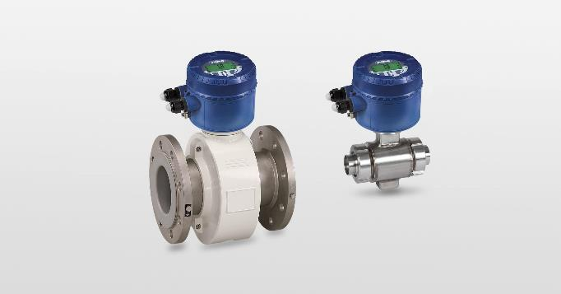

Photo: JUMO
Image caption: The flowmeters JUMO flowTRANS MAG S10 and H10 make an impression with simple startup and high measuring accuracy.
Press release
PI 2175

Page 2 of 2

The JUMO corporate group, with corporate headquarters in Fulda, employs around 2,300 people worldwide and is one of the leading manufacturers in the field of industrial sensor and automation technology. JUMO products are used around the globe in industries such as heating and air conditioning, food and beverage, renewable energies, water and wastewater, and industrial furnace construction. The corporate group encompasses 5 branch offices in Germany, 25 subsidiaries in Germany and abroad, and more than 40 agencies around the world. The company posted a turnover of 248 million euro in 2018.


