The New Paperless Recorder
JUMO LOGOSCREEN 600
Press release
PI 1992

Page 1 of 2

Editorial information:
Michael Brosig, Press Office
Phone: +49 661 6003-238
Fax: +49 661 6003-682
Email: michael.brosig@jumo.net

Technical information:
Manfred Walter, Product Manager
Phone: +49 661 6003-498
Fax: +49 661 6003-881498
Email: manfred.walter@jumo.net

JUMO GmbH & Co. KG

Moritz-Juchheim-Str. 1
36039 Fulda, Germany

Phone: +49 661 6003-0
Fax: +49 661 6003-500

Email: mail@jumo.net
Internet: www.jumo.net
Proven technology with an innovative operating concept

The new LOGOSCREEN 600 combines JUMO's long-standing experience of paperless recorders with a new control and visualization concept. With the ICON-based system, in most cases only a maximum of three "touch movements" are required to display the desired process data.
Different versions of the JUMO LOGOSCREEN 600 are available for process data recording. The basic model is a device version without measuring input in which up to 24 analog and digital process values are received from external systems in slave or master operating mode via an Ethernet interface with Modbus TCP or RS485 interface with Modbus RTU. The top-of-the-line models are variants with three or six universal analog inputs, two analog outputs, 12 digital inputs, and 12 individually switchable digital inputs/outputs. The compact design with a mounting depth of 119 mm (including connecting plug) permits insertion even in control cabinets with little depth.
The measurement signals are stored in the internal memory according to groups with a configurable memory cycle time from 125 milliseconds up to 32,000 seconds. The data can be extracted using a USB flash drive or via an Ethernet interface.
In the JUMO LOGOSCREEN 600, the connected process signals can be displayed with the default visualizations such as line graphs (vertical or horizontal), bar graphs, text images (numerical), or digital diagrams. In addition, users can use the setup program to create up to six separate process screens according to their individual requirements.
With the flexibly adjustable batch recording, important production data is safely stored and archived for subsequent backtracking of production processes. The powerful PCA3000 PC program is available for the evaluation of data and the PCC communication software is available for automatic data retrieval. The practical setup program allows the extremely compact paperless recorder to be easily and reliably configured for a quick startup. When connected to an Ethernet network, the installed web server enables remote requests via Internet browser.
In addition, monitoring of the JUMO LOGOSCREEN 600 is also possible with the new JUMODevice app.
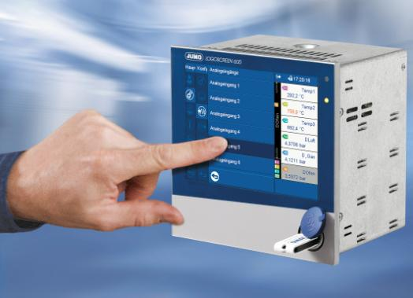

Image caption: The new JUMO LOGOSCREEN 600 paperless recorder combines proven technology with an innovative operating concept.

The JUMO corporate group, headquartered in Fulda, employs more than 2,200 people worldwide and is one of the leading manufacturers in the field of industrial sensor and automation technology. JUMO products are used around the globe in industries such as "heating and air conditioning", "food and beverage", "renewable energies", and "water and wastewater". The corporate group encompasses five branch offices in Germany, 24 subsidiaries abroad, and more than 40 agencies around the world. The company posted a turnover of 221 million euro in 2014.
Press release
PI 1992

Page 2 of 2

