JUMO TYA 203 Expands
SCR Power Controller Series
Press release
PI 1991

Page 1 of 2

Editorial information:
Michael Brosig, Press Office
Phone: +49 661 6003-238
Fax: +49 661 6003-682
Email: michael.brosig@jumo.net

Technical information:
Andreas Kraus, Product Manager
Phone: +49 661 6003-2394
Fax: +49 661 6003-882394
Email: andreas.kraus@jumo.net

JUMO GmbH & Co. KG

Moritz-Juchheim-Str. 1
36039 Fulda, Germany

Phone: +49 661 6003-0
Fax: +49 661 6003-500

Email: mail@jumo.net
Internet: www.jumo.net
New communication protocol for all devices in the series

The JUMO power controller series is being supplemented with the new device type TYA 203, a fully fledged three-phase power controller. This enables the actuation of three-phase loads in three-phase networks with all operating modes and the simultaneous detection of partial load failures.
The new power controller is typically used in furnace construction, where temperatures of 1400 °C and higher need to be reached. Silicon carbide and molybdenum disilicide are used as the heating elements. Both materials have particular electrical features that can be activated easily with the JUMO TYA power controllers.
A further advantage is the "Teach-in" function, which allows the alarm limit values for the detection of partial load failures to be set automatically. The cyclical calibration ensures permanent and precise detection of partial load failure, even if the specifications of the heating element are changed. The TYA 203 series is available in currents from 20 to 250 A and mains voltages of up to 500 V.
In addition, in future all the JUMO power controllers will be equipped with a new, Ethernet-based communication protocol. The new interface provides more data in a shorter time. This also enables the constant transfer of process data such as load current, load voltage, and impedance. However, specifications on energy consumption and diagnosis functions such as mains voltage fluctuations, partial load failure, and excess temperature are also evaluated.
The real-time capability of the interface enables several power controllers to be synchronized in combination with the JUMO mTRON T automation system. In addition, this capability also enables the management of load currents. The system determines the overall output of the process and regulates the individual output of the power controllers to prevent the system from exceeding the predefined current limits. This avoids energy peaks and reduces power costs.

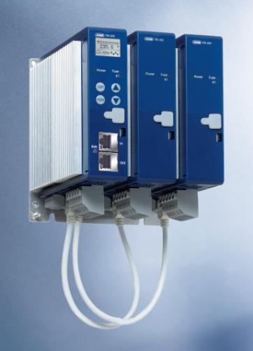

Image caption: With the TYA 203, JUMO is presenting a three-phase SCR power controller with an Ethernet-based communication protocol.

The JUMO corporate group, headquartered in Fulda, employs more than 2,200 people worldwide and is one of the leading manufacturers in the field of industrial sensor and automation technology. JUMO products are used around the globe in industries such as "heating and air conditioning", "food and beverage", "renewable energies", and "water and wastewater". The corporate group encompasses five branch offices in Germany, 24 subsidiaries abroad, and more than 40 agencies around the world. The company posted a turnover of 221 million euro in 2014.
Press release
PI 1991

Page 2 of 2

