A True All-Rounder
Press release
PI 2228

Page 1 of 2

Editorial information:
Michael Brosig, Press Office
Phone: +49 661 6003-238
Fax: +49 661 6003-881238
Email: michael.brosig@jumo.net

Technical information:
Joachim Vollmer, Product Manager
Phone: +49 661 6003-231
Fax: +49 661 6003-881231
Email: joachim.vollmer@jumo.net

JUMO GmbH & Co. KG

Moritz-Juchheim-Strasse 1
36039 Fulda, Germany

Phone:+49 661 6003-0
Fax: +49 661 6003-500

Email: mail@jumo.net
Internet: www.jumo.net
Press release
PI 2218

Editorial information:
Michael Brosig, Press Office
Phone: +49 661 6003-2788
Fax: +49 661 6003-882788
Email: michael.brosig@jumo.net

Technical information:
Manfred Walter, Product Manager
Phone: +49 661 6003-498
Fax: +49 661 6003-881498
Email: manfred.walter@jumo.net

JUMO GmbH & Co. KG

Moritz-Juchheim-Strasse 1
36039 Fulda, Germany

Phone: +49 661 6003-0
Fax: +49 661 6003-500

Email: mail@jumo.net
Internet: www.jumo.net
The JUMO TAROS S47 P precision pressure transmitter

JUMO TAROS S47 P is used for acquiring relative and absolute pressures in liquid and gaseous media. Its excellent active temperature compensation ensures precise pressure measurements and therefore increased process reliability over a wide temperature range.
Press release
PI 2228

Editorial information:
Michael Brosig, Press Office
Phone: +49 661 6003-2788
Fax: +49 661 6003-882788
Email: michael.brosig@jumo.net

Technical information:
Joachim Vollmer, Product Manager
Phone: +49 661 6003-231
Fax: +49 661 6003-881231
Email: joachim.vollmer@jumo.net

JUMO GmbH & Co. KG

Moritz-Juchheim-Strasse 1
36039 Fulda, Germany

Phone: +49 661 6003-0
Fax: +49 661 6003-500

Email: mail@jumo.net
Internet: www.jumo.net

The robust construction enables protection types up to IP69 and therefore use in all areas, regardless of the environmental influences. Default measuring ranges for the JUMO TAROS S47 P lie between 0 to 100 bar relative pressure and 0 to 40 bar absolute pressure. The medium temperature can be between -40 and +125°°C. It can even be 140 °C for a maximum of 1 hour per day. Linearity and long-term stability are both very low at 0.1 percent. The overall accuracy at 20 °C is at the most 0.25 percent of the measuring span.

The zero point correction can easily be carried out with a magnet. This way, the pressure transmitter delivers reliable measured values over a long time. A wide range of process connections are available for the compact design of the JUMO TAROS S47 P. Cable fittings, M12 × 1 round plugs, line sockets, or terminal cases are available as electrical connections.

One area in which the precision transmitter is used is mechanical and plant engineering, but it is also suitable for pumps or sterilizers. Test equipment construction, calibration technology, and laboratories are also areas in which the JUMO TAROS S47 P can be used.

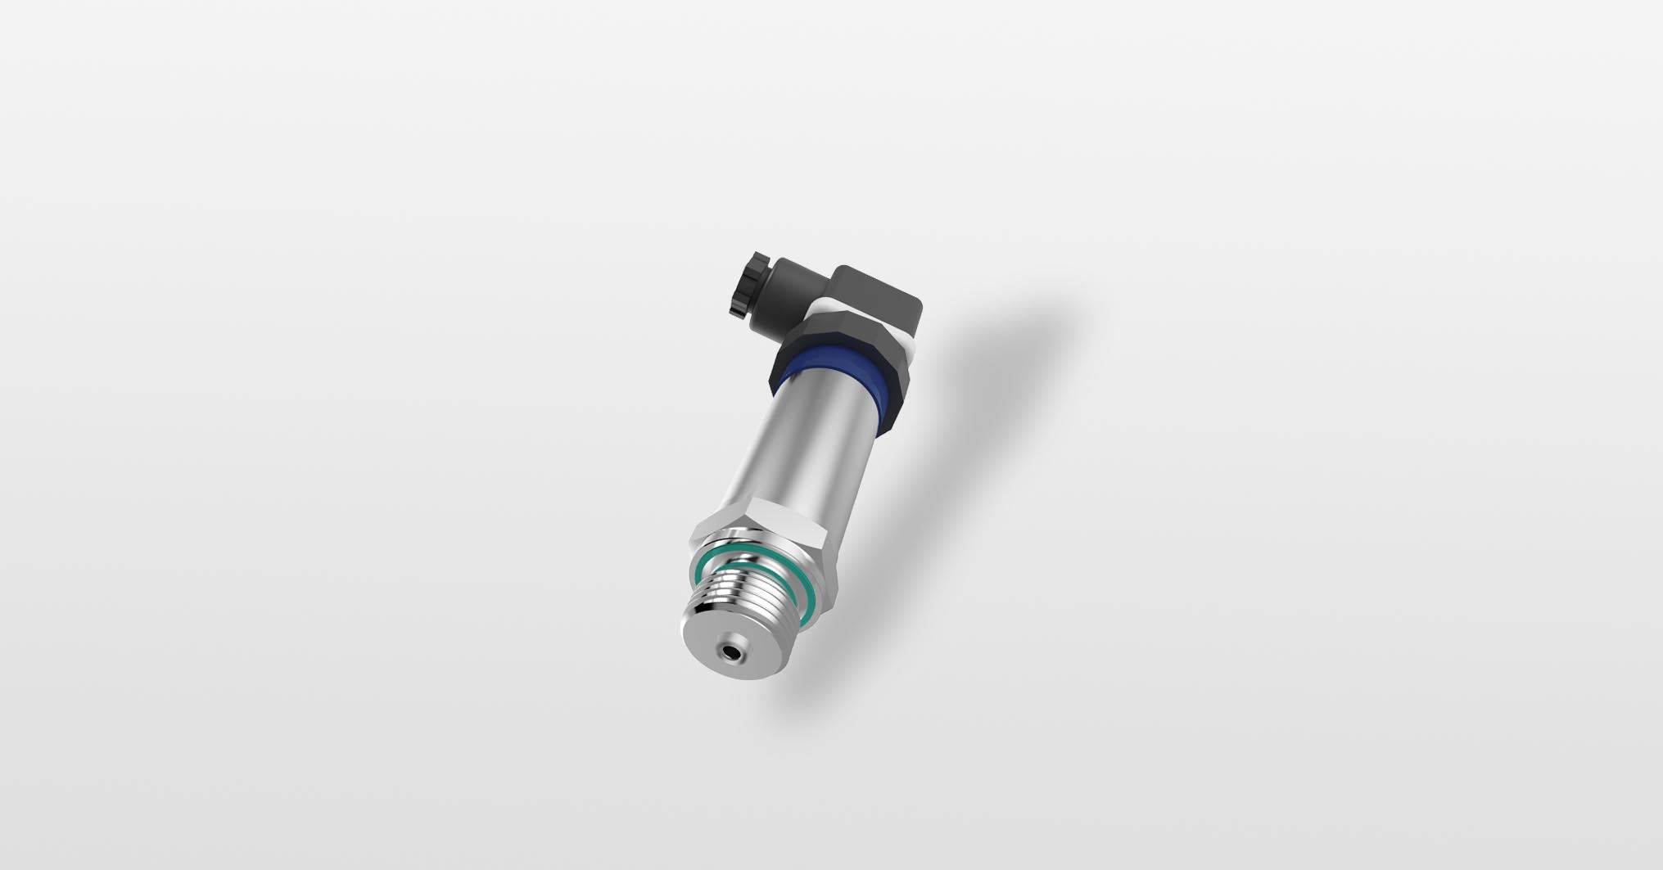
Photo: JUMO

Image caption: The JUMO TAROS S47 P precision pressure transmitter is suitable for a wide variety of industries and applications.
Press release
PI 2228

Page 2 of 2

The JUMO corporate group, headquartered in Fulda, Germany employs around 2 400 people worldwide and is one of the leading manufacturers in the field of industrial sensor and automation technology. JUMO products are used around the globe in industries such as heating and air conditioning, food and beverage, renewable energies, water and wastewater, and industrial furnace construction. The corporate group encompasses 5 branch offices in Germany, 25 subsidiaries in Germany and abroad, and more than 40 agencies around the world. The company posted a turnover of 253 million euro in 2019.


