JUMO Ex-i Isolating Switch Amplifier
Press release
PI 2218

Page 1 of 2

Editorial information:
Michael Brosig, Press Office
Phone: +49 661 6003-238
Fax: +49 661 6003-881238
Email: michael.brosig@jumo.net

Technical information:
Manfred Walter, Product Manager
Phone: +49 661 6003-498
Fax: +49 661 6003-881498
Email: manfred.walter@jumo.net

JUMO GmbH & Co. KG

Moritz-Juchheim-Strasse 1
36039 Fulda, Germany

Phone:+49 661 6003-0
Fax: +49 661 6003-500

Email: mail@jumo.net
Internet: www.jumo.net
2 channels and versatile application possibilities

Press release
PI 2218

Editorial information:
Michael Brosig, Press Office
Phone: +49 661 6003-2788
Fax: +49 661 6003-882788
Email: michael.brosig@jumo.net

Technical information:
Manfred Walter, Product Manager
Phone: +49 661 6003-498
Fax: +49 661 6003-881498
Email: manfred.walter@jumo.net

JUMO GmbH & Co. KG

Moritz-Juchheim-Strasse 1
36039 Fulda, Germany

Phone: +49 661 6003-0
Fax: +49 661 6003-500

Email: mail@jumo.net
Internet: www.jumo.net
The two-channel JUMO Ex-i isolating switch amplifier represents a new product category within the extensive JUMO portfolio. It was developed especially for the float switches from the JUMO NESOS series, but also supports all proximity sensors in accordance with the NAMUR standard.

The intrinsically safe isolating switch amplifier is a new addition to the JUMO Safety portfolio that enables reliable, galvanic 3-way isolation as well as safe transfer of switching signals – for both normal and Ex applications. It can be used in an extended ambient temperature range of -40 to +60 °C, has ATEX and IECEx approval, and can also be mounted in Ex zone 2. The connected float switch contact or proximity sensor can be operated up to zone 0. In addition, the JUMO Ex-i isolating switch amplifier has UL as well as DNV GL approval and meets SIL 2 in safety-related applications. A changeover relay with a phase reversal option per channel is available as a switching output.

A line failure detection system identifies line breaks or short circuits which ensures a high degree of process reliability. This makes the JUMO Ex-i isolating switch amplifier a reliable partner for a wide range of applications in mechanical and plant engineering, the chemical industry, the food technology sector, and many other areas.

By integrating 2 channels in 1 device, the JUMO Ex-i isolating amplifier requires very little space during installation. Its coded screw terminals and simple configuration with DIP switches help to save time during startup. LEDs indicate the respective status directly on the device. The use of a wide-range power supply unit (24 to 230 V AC/DC) reduces storage costs.

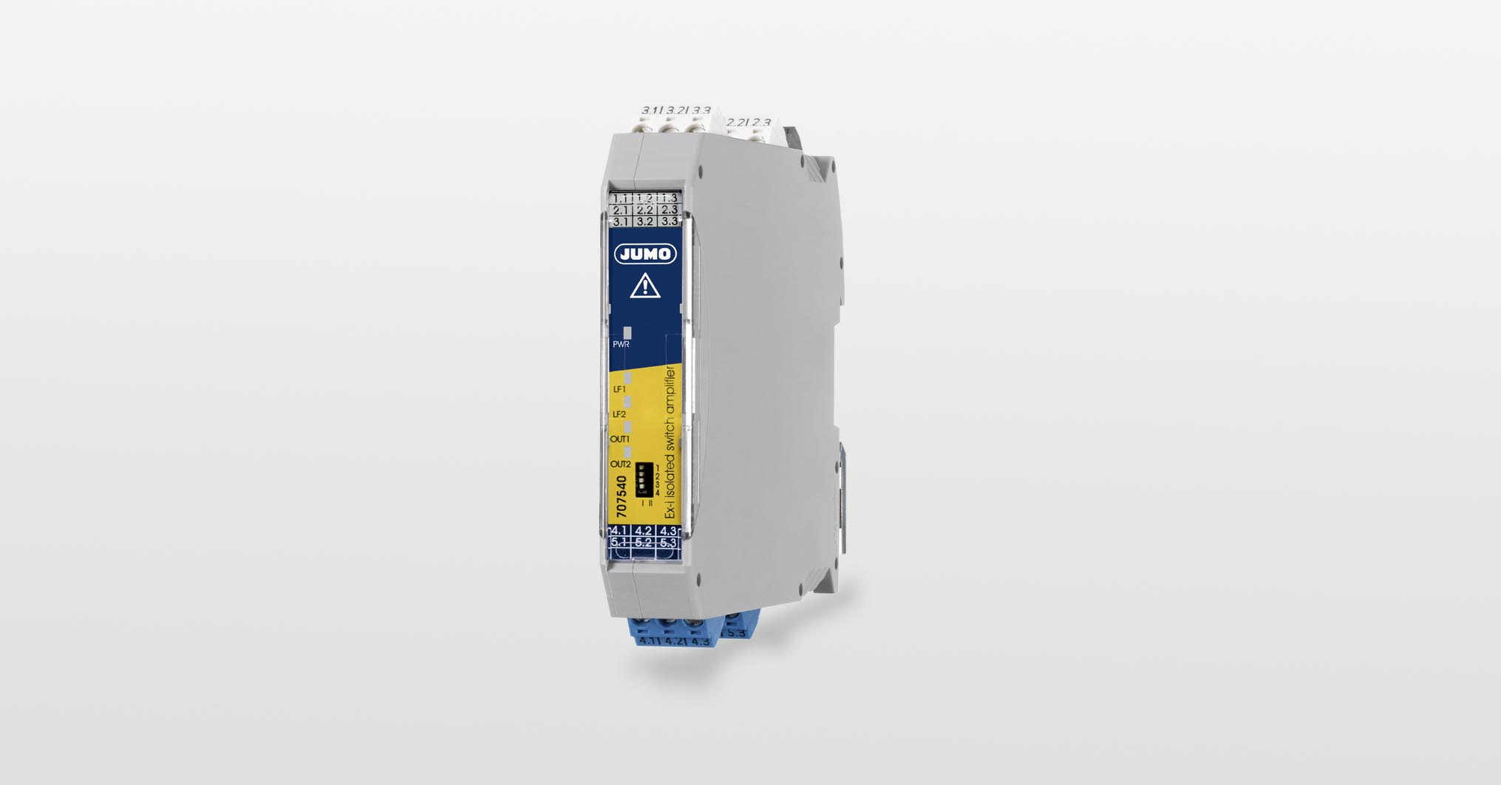
Photo: JUMO

Image caption: The two-channel JUMO Ex-i isolating switch amplifier takes up very little space when installed and is particularly easy to put into operation.
Press release
PI 2218

Page 2 of 2

The JUMO corporate group, headquartered in Fulda, Germany employs around 2 400 people worldwide and is one of the leading manufacturers in the field of industrial sensor and automation technology. JUMO products are used around the globe in industries such as heating and air conditioning, food and beverage, renewable energies, water and wastewater, and industrial furnace construction. The corporate group encompasses 5 branch offices in Germany, 25 subsidiaries in Germany and abroad, and more than 40 agencies around the world. The company posted a turnover of 253 million euro in 2019.


