JUMO Transmitters for SIL and Ex
Press release
PI 2200

Page 1 of 2

Editorial information:
Michael Brosig, Press Office
Phone: +49 661 6003-238
Fax: +49 661 6003-881238
Email: michael.brosig@jumo.net

Technical information:
Manfred Walter, Product Manager
Phone: +49 661 6003-498
Fax: +49 661 6003-881498
Email: manfred.walter@jumo.net

JUMO GmbH & Co. KG

Moritz-Juchheim-Strasse 1
36039 Fulda, Germany

Phone: +49 661 6003-0
Fax: +49 661 6003-500

Email: mail@jumo.net
Internet: www.jumo.net
Intuitive operation and excellent reliability

The new JUMO dTRANS T06 Ex multifunction four-wire transmitter in a mounting rail case is suitable for use in challenging SIL and Ex applications.

Its measurement input features 22-bit resolution with selectable noise suppression and is extremely precise. The SIL option fulfills the requirements of SIL 2 / SIL 3 according to DIN EN 61508 and PL c / PL d according to DIN EN ISO 13849. The JUMO dTRANS T06 Ex also meets the ATEX and IECEx requirements up to zone 0.

A particularly high galvanic isolation guarantees excellent signal stability, even when measuring conditions are difficult. Intuitive operation takes place via 4 keys and an LCD display, which can also be used to display information about the measuring point. Reliable SIL configuration is facilitated by an easy-to-use setup program. As a special feature, the device display can also be used to access a connection diagram that is based on the configuration.

The device can be used with RTD temperature probes, thermocouples, resistance transmitters, as well as voltage and current signals. It converts the input signal into an output signal (0(2) to 10 V or 0(4) to 20 mA). The universal measurement input with 22-bit resolution ensures maximum measuring precision with the JUMO dTRANS T06 Ex.

The compact mounting rail case, which has a design width of just 22.5 mm, and the encoded plug-in terminals enable the device to be quickly installed into control cabinets. In addition, the device can be reliably replaced when performing calibration and maintenance work. All the important information regarding the transmitter can be queried and visualized via an RS485 interface.

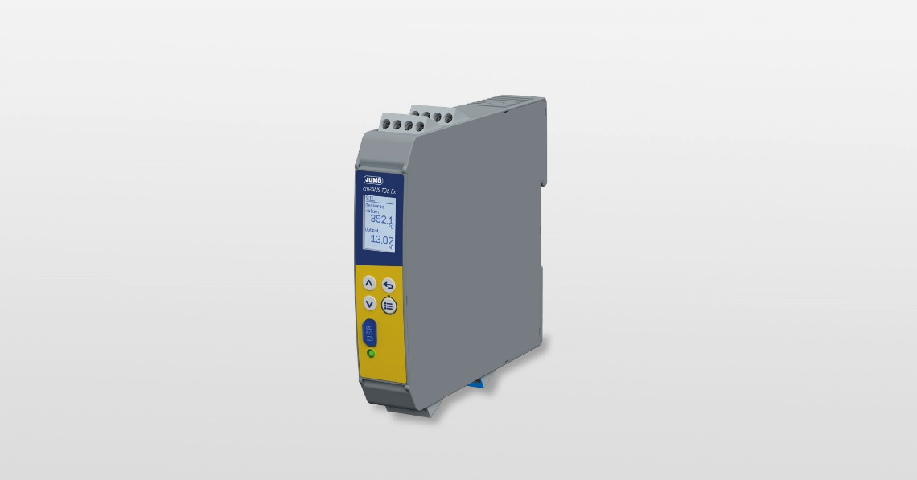

Photo: JUMO
Image caption: JUMO developed the dTRANS T06 Ex transmitter for use in particularly challenging safety and Ex applications.
Press release
PI 2200

Page 2 of 2

The JUMO corporate group, headquartered in Fulda, Germany employs around 2 400 people worldwide and is one of the leading manufacturers in the field of industrial sensor and automation technology. JUMO products are used around the globe in industries such as heating and air conditioning, food and beverage, renewable energies, water and wastewater, and industrial furnace construction. The corporate group encompasses 5 branch offices in Germany, 25 subsidiaries in Germany and abroad, and more than 40 agencies around the world. The company posted a turnover of 253 million euro in 2019.


