Simply Making Good Things Even Better
Press release
PI 2172

Page 1 of 2

Editorial information:
Michael Brosig, Press Office
Phone: +49 661 6003-238
Fax: +49 661 6003-881238
Email: michael.brosig@jumo.net

Technical information:
Klaus Otto, Product Manager
Phone: +49 661 6003-562
Fax: +49 661 6003-508
Email: klaus.otto@jumo.net

JUMO GmbH & Co. KG

Moritz-Juchheim-Strasse 1
36039 Fulda, Germany

Phone: +49 661 6003-0
Fax: +49 661 6003-500

Email: mail@jumo.net
Internet: www.jumo.net
Process and program controller JUMO DICON touch with many new functions

The functional range of the proven process and program controller JUMO DICON touch has been extended by numerous new features. Extensive control tasks can be implemented via 4 instead of 2 control channels. Several control zones can thereby be managed in a space-saving manner with just 1 device.

Up to 4 user editable process screens enable individual visualizations, fast access to process states, and simple as well as straightforward operation.

The DICON touch offers the right solution even for complex applications with the function extension to 16 math and logic formulas as well as 4 timers. Even extensive time-controlled processes can be implemented with a high degree of flexibility in the new version via 32 user programs and 16 operating contacts. In addition, the integrated recording function offers sustainable and tamper-proof data acquisition of 8 analog and 16 digital values.

The DICON touch can be individually adapted to the respective requirement with the outstanding control algorithm, the modular structure, as well as the communication possibilities via the interfaces USB host, USB device, RS422/485 Modbus master or slave, PROFIBUS DP, Ethernet, and PROFINET IO device.

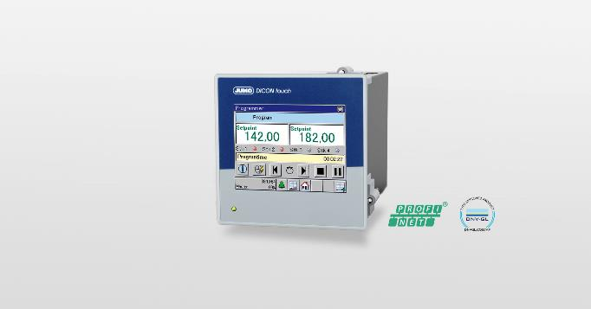

Photo: JUMO
Image caption: The JUMO DICON touch process and program controller now monitors 4 control channels precisely and reliably.
Press release
PI 2172

Page 2 of 2

The JUMO corporate group, with corporate headquarters in Fulda, employs around 2,300 people worldwide and is one of the leading manufacturers in the field of industrial sensor and automation technology. JUMO products are used around the globe in industries such as heating and air conditioning, food and beverage, renewable energies, water and wastewater, and industrial furnace construction. The corporate group encompasses 5 branch offices in Germany, 25 subsidiaries in Germany and abroad, and more than 40 agencies around the world. The company posted a turnover of 248 million euro in 2018.
