Robust and Reliable Cable Transmitter for Temperature
Press release
PI 2171

Page 1 of 2

Editorial information:
Michael Brosig, Press Office
Phone: +49 661 6003-238
Fax: +49 661 6003-881238
Email: michael.brosig@jumo.net

Technical information:
Manfred Walter, Product Manager
Phone: +49 661 6003-498
Fax: +49 661 6003-881498
Email: manfred.walter@jumo.net

JUMO GmbH & Co. KG

Moritz-Juchheim-Strasse 1
36039 Fulda, Germany

Phone: +49 661 6003-0
Fax: +49 661 6003-500

Email: mail@jumo.net
Internet: www.jumo.net
JUMO dTRANS T09 retrofits plants

The JUMO dTRANS T09 temperature transmitter is ideal for simple retrofitting of plants. High vibration and shock resistance make the device particularly reliable. The cable transmitter with 4-wire connection for RTD temperature probes is available with an analog output (4 to 20 mA) or an IO-Link interface.

Pt100 or Pt1000 sensors can be used in the JUMO dTRANS T09. The high-quality stainless steel case is available in protection types IP65, IP67, and IP69. Connection takes place on both sides using Plug and Play with M12 connectors. Pre-assembled cables for M12 connections on both sides, which are also available, can prevent wiring errors and thereby reduce mounting and maintenance costs.

Due to its design the JUMO dTRANS T09 is largely insulated from process influences so that it is particularly robust and durable.

The version with IO-Link interface optimizes production processes through communication down to the lowest field level and offers maximum transparency of the measured values and sensor states. This interface also contains a switching output. As a result, temperature measurement and monitoring is possible with only 1 device. This variant can also be used, for example, to digitize plants during a short standstill.

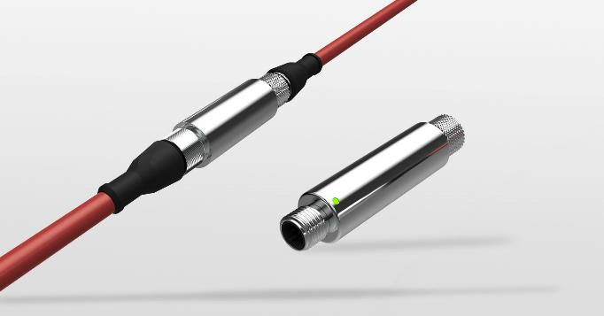

Photo: JUMO
Image caption: The JUMO dTRANS T09 temperature transmitter stands out due to its particularly high vibration and shock resistance.
Press release
PI 2171

Page 2 of 2

The JUMO corporate group, with corporate headquarters in Fulda, employs around 2,300 people worldwide and is one of the leading manufacturers in the field of industrial sensor and automation technology. JUMO products are used around the globe in industries such as heating and air conditioning, food and beverage, renewable energies, water and wastewater, and industrial furnace construction. The corporate group encompasses 5 branch offices in Germany, 25 subsidiaries in Germany and abroad, and more than 40 agencies around the world. The company posted a turnover of 248 million euro in 2018.


