A Paperless Recorder for All Situations
Press release
PI 2170

Page 1 of 2

Editorial information:
Michael Brosig, Press Office
Phone: +49 661 6003-238
Fax: +49 661 6003-881238
Email: michael.brosig@jumo.net

Technical information:
Manfred Walter, Product Manager
Phone: +49 661 6003-498
Fax: +49 661 6003-881498
Email: manfred.walter@jumo.net

JUMO GmbH & Co. KG

Moritz-Juchheim-Strasse 1
36039 Fulda, Germany

Phone: +49 661 6003-0
Fax: +49 661 6003-500

Email: mail@jumo.net
Internet: www.jumo.net
Secure and flexible data acquisition with the JUMO LOGOSCREEN 601

The new JUMO LOGOSCREEN 601 is a flexible paperless recorder with up to 6 internal analog measuring channels. Its high degree of interface flexibility enables its use for various tasks in industrial furnace construction as well as in the pharmaceutical, food, water, and wastewater industries. Individual adaptations to your own applications can be made using ST code.

Operation of the paperless recorder is performed via a color display with touchscreen. The universal measuring inputs are designed for RTD temperature probes, thermocouples, and standard signals.

Particular emphasis was placed on security in the development of the new paperless recorder. The device offers the highest degree of security during data acquisition through manipulation detection based on the latest hash algorithms with digital certificate. A security manager enables FDA compliant data recording. An optional sealable rear wall cover allows use in industries with high security requirements.

Depending on the version, the JUMO LOGOSCREEN 601 has up to 12 individually switchable digital inputs/outputs, 6 digital inputs, 2 analog outputs as voltage output 0 to 10 V or current output 0(4) to 20 mA,1 relay output, and up to 2 counting inputs. Interface standard: RS232/485 for barcode scanner, Ethernet and USB (host/device), as well as RS485/TCP for Modbus client and server. The optional PROFINET IO device interface enables the transmission and recording of up to 24 analog and 24 digital process signals.

Highly-adaptable batch recording enables important production data to be securely recorded and archived for later tracing of manufacturing processes. Up to 6 customer-specific process screens are available for visualizing the plant or depiction of the process states.

All these functions are accommodated in space-saving housing with a mounting depth of only 121 mm. Additionally, by using PUSH IN terminals the JUMO LOGOSCREEN 601 can start running especially quickly.

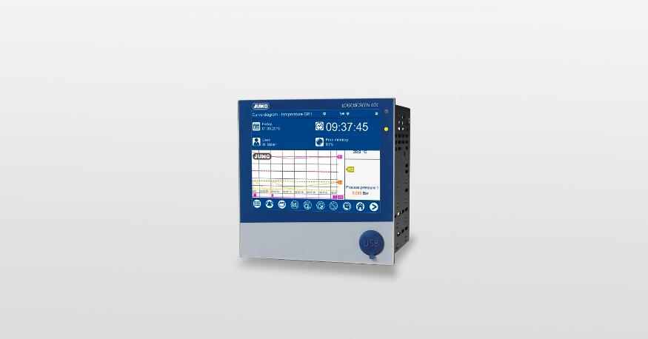

Photo: JUMO
Image caption: The JUMO LOGOSCREEN 601 paperless recorder places the priority on "interface flexibility" and "security".
Press release
PI 2170

Page 2 of 2

The JUMO corporate group, headquartered in Fulda, Germany employs around 2 300 people worldwide and is one of the leading manufacturers in the field of industrial sensor and automation technology. JUMO products are used around the globe in industries such as heating and air conditioning, food and beverage, renewable energies, water and wastewater, and industrial furnace construction. The corporate group encompasses 5 branch offices in Germany, 25 subsidiaries in Germany and abroad, and more than 40 agencies around the world. The company posted a turnover of 248 million euro in 2018.


