JUMO TAROS S46 H Ensures Process Reliability
Press release
PI 2160

Page 1 of 2

Editorial information:
Michael Brosig, Press Office
Phone: +49 661 6003-238
Fax: +49 661 6003-881238
Email: michael.brosig@jumo.net

Technical information:
Hubert Jakob, Product Manager
Phone: +49 661 6003-2375
Fax: +49 661 6003-882375
Email: hubert.jakob@jumo.net

JUMO GmbH & Co. KG

Moritz-Juchheim-Strasse 1
36039 Fulda, Germany

Phone: +49 661 6003-0
Fax: +49 661 6003-500

Email: mail@jumo.net
Internet: www.jumo.net
Hygienic pressure transmitter with protection classes up to IP69

The pressure transmitter JUMO TAROS S46 H is designed according to hygienic requirements for precision measurement and longevity. The high-level protection type and the fully welded, compact design enable residue-free cleaning processes and high temperature compatibility for SIP and CIP processes. Its excellent active temperature compensation ensures exact pressure measurements and thereby improved process reliability.

JUMO TAROS S46 H is an ideal partner for the food industry, CIP and SIP applications, sterilizers, and autoclaves as well as for all hygienic pressure measurement applications. The pressure transmitter also ensures maximum operational safety in the pharmaceutical, medical, and biotechnology industries. Protection classes from IP65 to IP69 enable use in all areas, regardless of the environmental influences. The use of FDA compliant materials and hygienic process connections (clamp, VARIVENT, JUMO PEKA) guarantees safety and good cleanability.

The default measuring ranges of the JUMO TAROS S46 H are between 0 and 100 bar. An autoclavable version is available for special applications. The medium temperature can be between -40 and +125 °C. For a maximum of 1 hour per day the medium temperature can even be at 140 °C, which is ideal for CIP and SIP applications. Linearity and long-term stability are both very low at 0.1 %. The total accuracy at 20 °C is at the most 0.25 % of the measuring span.

The zero point correction can easily be carried out with a magnet (e.g. after the autoclave process). This way, the pressure transmitter delivers reliable measured values even over a long period.

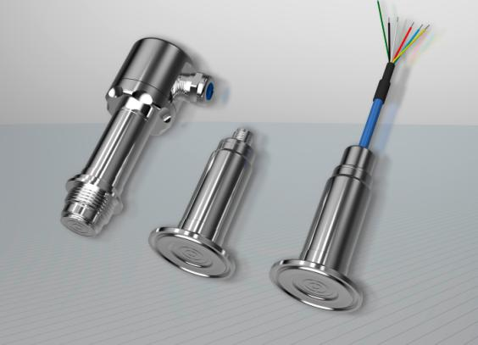

Photo: JUMO
Image caption: The hygienic pressure transmitter JUMO TAROS S46 H is particularly precise and durable.
Press release
PI 2160

Page 2 of 2

The JUMO corporate group, headquartered in Fulda, Germany employs around 2 300 people worldwide and is one of the leading manufacturers in the field of industrial sensor and automation technology. JUMO products are used around the globe in industries such as heating and air conditioning, food and beverage, renewable energies, water and wastewater, and industrial furnace construction. The corporate group encompasses 5 branch offices in Germany, 25 subsidiaries in Germany and abroad, and more than 40 agencies around the world. The company posted a turnover of 248 million euro in 2018.


