Endless Possibilities with the JUMO LOGOSCREEN 700
Press release
PI 2149

Page 1 of 2

Editorial information:
Michael Brosig, Press Office
Phone: +49 661 6003-238
Fax: +49 661 6003-881238
Email: michael.brosig@jumo.net

Technical information:
Manfred Walter, Product Manager
Phone: +49 661 6003-498
Fax: +49 661 6003-881498
Email: manfred.walter@jumo.net

JUMO GmbH & Co. KG

Moritz-Juchheim-Strasse 1
36039 Fulda, Germany

Phone: +49 661 6003-0
Fax: +49 661 6003-500

Email: mail@jumo.net
Internet: www.jumo.net
Highly scalable paperless recorder with intuitive operation

The JUMO LOGOSCREEN 700 is the new top-of-the range model from the successful JUMO paperless recorder series. It is highly scalable in terms of measurement input and output cards so that it can be adapted flexibly to different applications. These equipment options range from a device version without measurement input to versions with a maximum of 18 measurement inputs, 3 analog outputs, 18 digital inputs, 24 individually switchable digital inputs and outputs, and 7 relay outputs.

The device comes with a shallow depth of just 119 mm, thereby saving valuable space during installation. Furthermore, startup of the device is reliable and simple due to PUSH IN terminals. The 5.7" TFT color screen is touch based. The ICON-based system in most cases only requires a maximum of 3 "touch movements" to display the requested process data.

Through a PROFINET interface up to 60 analog and digital channels can be recorded as well as 120 external analog and digital inputs displayed. The device also has up to 8 counter inputs, which facilitates flow measurement based on fast digital pulse generators.

Manipulation detection based on the latest hash algorithms with digital certificate ensures the highest level of security during data acquisition. A sealable terminal cover on the rear for the connections provides protection against unauthorized access to the sensor terminals.

Plant visualization or the display of process states is possible with up to 10 customer-specific process screens. Each of these can display up to 100 objects. By using "structured texts" (ST code) individual applications are implemented in a flexible manner. As a result the recording process data is even more reliable and incorrect entries are avoided. The process values can be displayed using an app on smartphones or tablets.

In the diagram view, the user can activate up to 2 help lines per measuring channel. This gives the user a faster overview and evaluation of process limits on the recorder and the PC. It also provides security when evaluating critical process signals.

Data is recorded in a variable memory cycle as of 125 ms and saved on a 1 GB internal memory medium. USB flash drives can be used as external storage devices. For documentation verification of quality-related data the user has access to up to 5 adaptable batch reports with automatic batch printout.

The JUMO LOGOSCREEN 700 has cULus approval, which is important for the North American market, and supports the FDA-compliant data recording according to 21 CFR Part 11. Furthermore, it meets the heat treatment requirements according to AMS2750 und CQI-9.
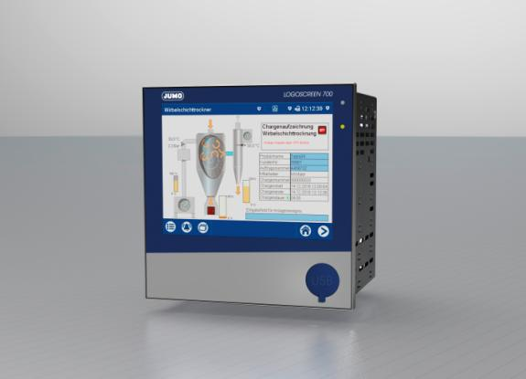

Photo: JUMO
Image caption: a paperless recorder for all requirements – the JUMO LOGOSCREEN 700
Press release
PI 2149

Page 2 of 2

