The Smart Way to Retrofit Your Dial Thermometers
Press release
PI 2152

Page 1 of 2

Editorial information:
Michael Brosig, Press Office
Phone: +49 661 6003-238
Fax: +49 661 6003-881238
Email: michael.brosig@jumo.net

Technical information:
Nico Müller, Product Manager
Phone: +49 661 6003-2879
Fax: +49 661 6003-882879
Email: nico.mueller@jumo.net

JUMO GmbH & Co. KG

Moritz-Juchheim-Strasse 1
36039 Fulda, Germany

Phone: +49 661 6003-0
Fax: +49 661 6003-500

Email: mail@jumo.net
Internet: www.jumo.net
Diverse temperature measurement with the JUMO dicoTEMP 100

The JUMO dicoTEMP 100 is a smart fitting with which various temperature measurements can be taken with one thermostat or dial thermometer and a platinum-chip temperature sensor from just one measuring point. The resistance signal is transformed into an analog or digital signal with the use of a transmitter.

The JUMO dicoTEMP 100 combines the strengths of several JUMO devices. With the new solution, users can continue to use any devices that are already part of the process at the same measuring point and, at the same time, extend them functionally with electrical temperature measurement.

The combination of a platinum-chip temperature sensor and a thermostat or dial thermometer in one fitting significantly reduces planning and installation effort.

The fitting is made from stainless steel and is available in different connection types: for screwing in or inserting to a flat tube. The insertion length varies between 65 and 300 mm, depending on the customer's wishes. The JUMO dicoTEMP 100 can be used at process temperatures ranging between -40 and +260 °C.

A resistance signal is transferred via an industry-standard M12 connector. Using a cable transmitter, other output signals can be relayed in an analog (4 to 20 mA) or digital (IO-Link) manner, which ensures the highest degree of flexibility in data use. In addition, great variability results from the use of different device types, platinum sensors, and probes as well as immersion sleeve diameters.

Its Plug and Play functionality makes the JUMO dicoTEMP 100 the ideal partner for retrofitting existing equipment such as transformers, compressors, and hydraulic units.

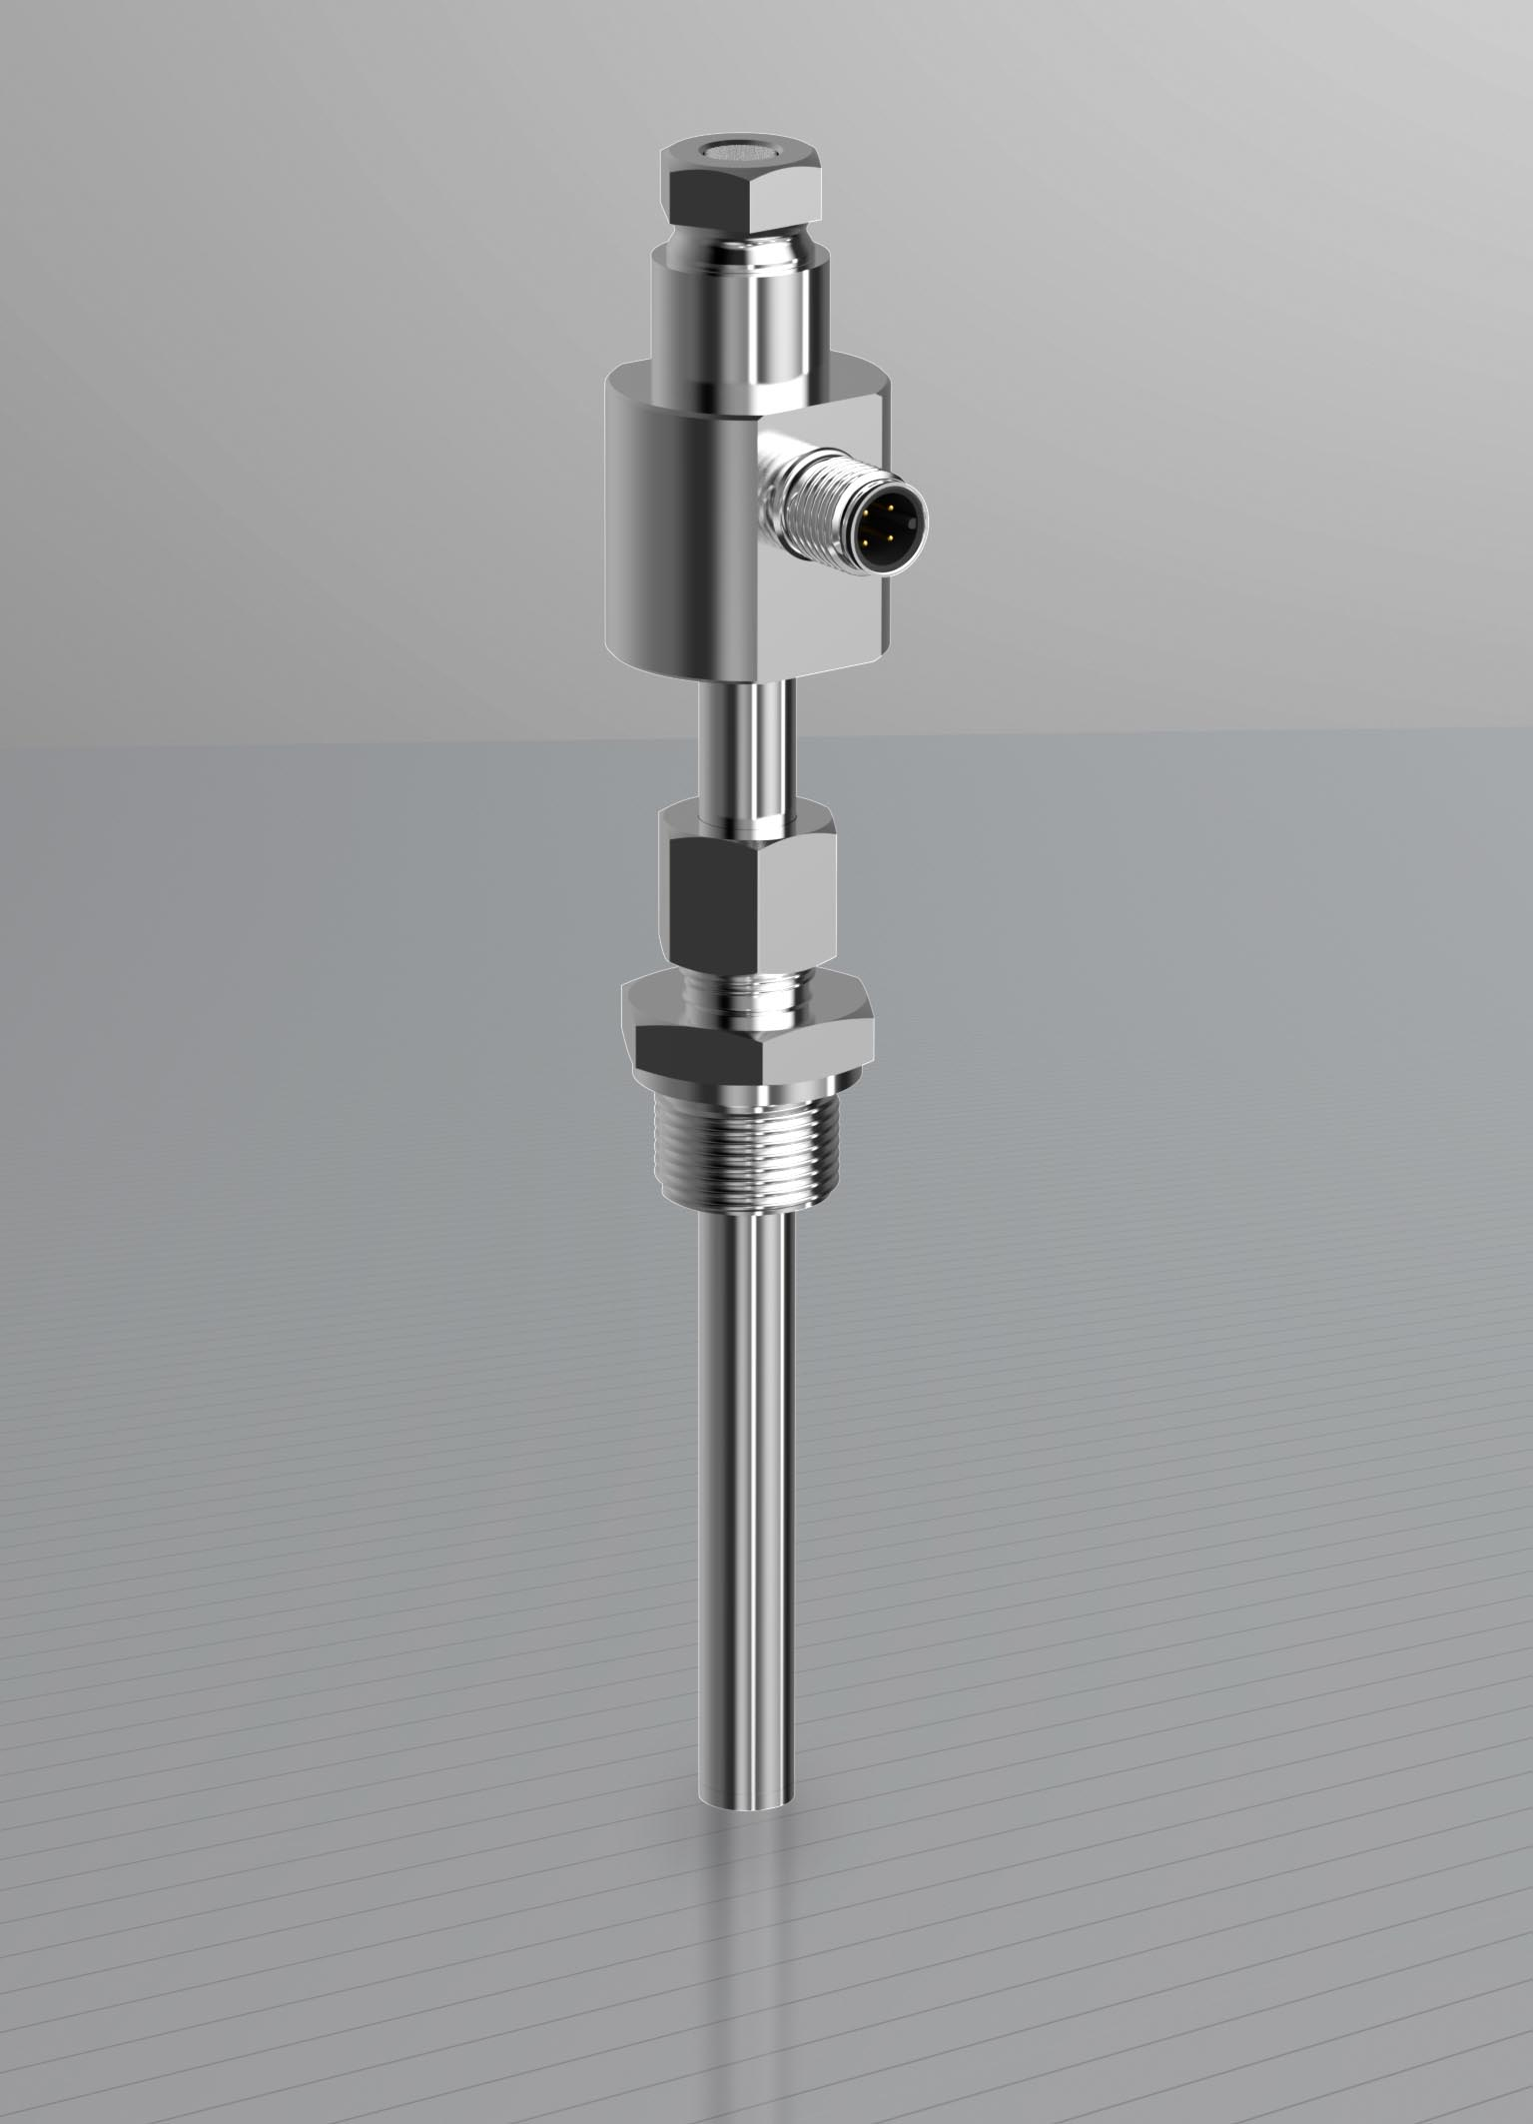

Photo: JUMO
Image caption: significantly less planning and installation effort as well as increased process reliability through diverse measurements are the features that set the JUMO dicoTEMP 100 apart.
Press release
PI 2152

Page 2 of 2

The JUMO corporate group, headquartered in Fulda, Germany employs around 2 300 people worldwide and is one of the leading manufacturers in the field of industrial sensor and automation technology. JUMO products are used around the globe in industries such as heating and air conditioning, food and beverage, renewable energies, water and wastewater, and industrial furnace construction. The corporate group encompasses 5 branch offices in Germany, 25 subsidiaries in Germany and abroad, and more than 40 agencies around the world. The company posted a turnover of 248 million euro in 2018.


